**Images – WRIQ Challenge – Draeger Australia**

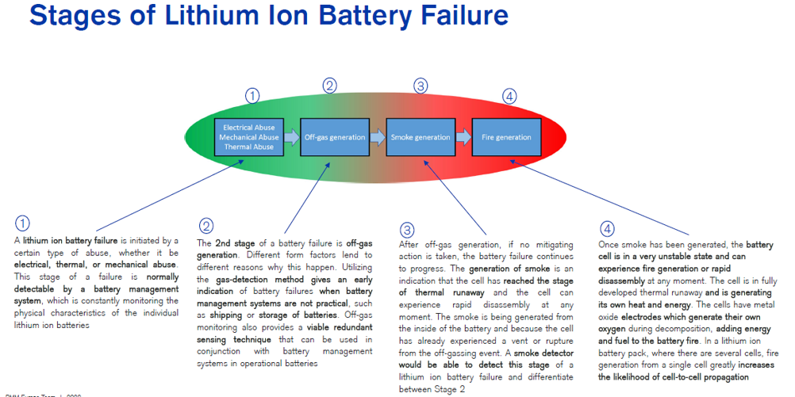

**Image 1 – 4 Stages of a Lithium-Ion Battery Fire**

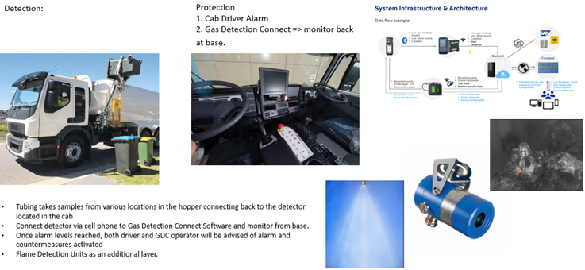

**Image 2 – Overview of Draeger Solutions**

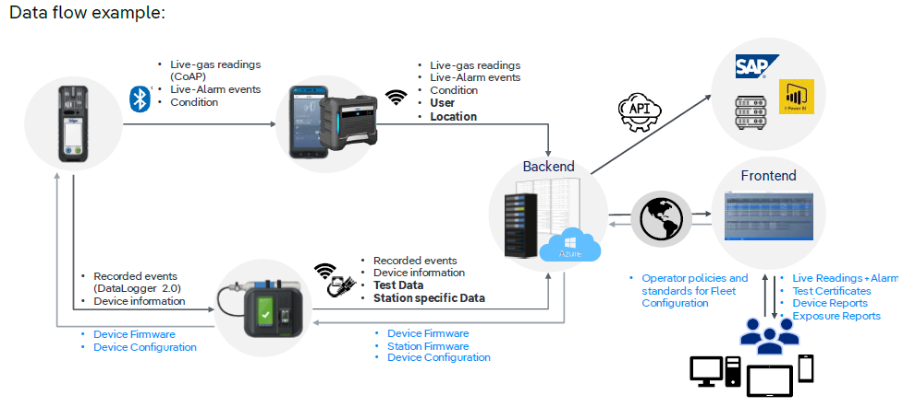

**Image 3 – Data flow of Gas Detection Connect Software**